Table of Contents
ICT - Form 3 2
Drama - Form 3 3
Chemistry - Form 3 4
MUSIC – FORM 3 5
Literature – Form 3 6
SOCIAL STUDIES - FORM 3 7
FRENCH - FORM 3 8
PHYSICAL EDUCATION – FORM 3 9
BIOLOGY - FORM 3 10
PHYSICS- FORM 3 11
VISUAL ARTS – FORM 3 12

ICT - Form 3
List Of Topics
Term I (2025-26)
1 Hardware Specifications
2 Careers
3 Computer Threats
4 Computer Crime
5 Algorithms
6 Flowcharts

Drama - Form 3
List Of Topics
Term I (2025-26)

• Icebreaker Introduction
• Theatre Spaces & Technical Theatre
• Floor Plans
• Floor Plan Construction
• Set Design
• Rituals – History of Theatre and the relevance of
• Props for a Dramatic Production
• Performance
• Technical Theatre – Lighting
• Technical Theatre – Sound
• Technical Theatre – Costume &Makeup
• Front of House
• Revision

Chemistry - Form 3
List of Topics
Term 1 2025/2026

- Review Writing Chemical Formulae & Balancing Equations
- Bonding

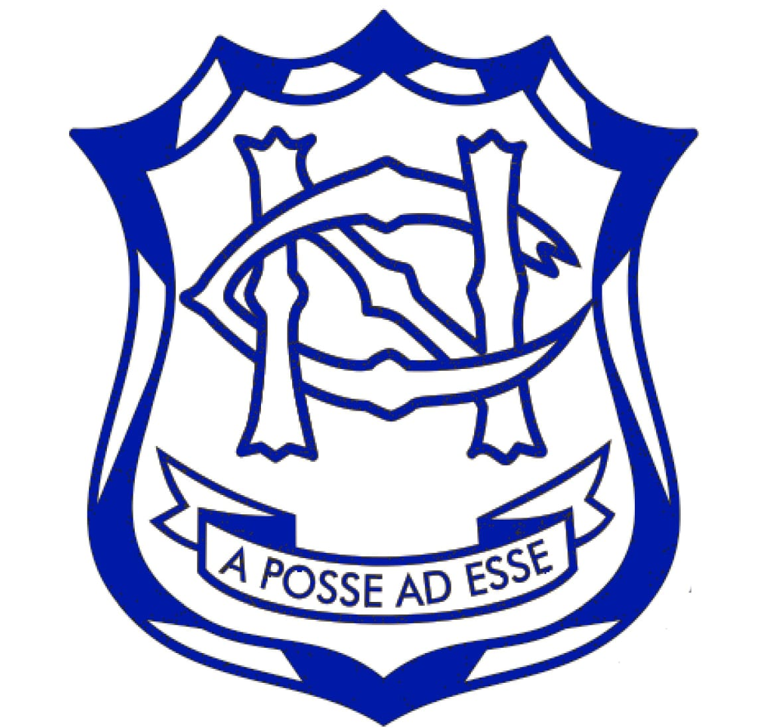

MUSIC – FORM 3
LIST OF TOPICS
TERM I (2025 - 2026)

- Pitch
- Rhythm
- Time Signatures
- Tempo

Literature – Form 3
LIST OF TOPICS
Term 1 (2025-2026)

POETRY
Understanding the elements of Poetry
The Solitary Reaper
My Grandmother
Hurt Hawks
Sonnet 73

PROSE
The Chrysalids
Chapters 1 - 7
Understanding the elements of Prose writing.
Review background on the Author. Comment on his Style of writing

DRAMA
The Merchant of Venice
Understanding the elements of Shakespearean Drama
Act 1 Scenes 1,2,3
Act 2 Scene 1

SOCIAL STUDIES - FORM 3
LIST OF TOPICS
TERM 1 2025/2026

- Economic Growth and Development: Chapter 3
  - Globalisation
  - Communication
  - Impact of ICT on Globalisation
  - Impact of ICT in the economy of T&T.
- Transport and Economic Development: Chapter 4
  - Impact of Transport on economic development
  - Importance of marketing and distribution
- Our Heritage:
  - National Heroes and National Icons: Chapter 1
  - Conservation and preservation of our heritage: Chapter 2
- Ethics and Relationships: Chapter5
- Humanitarian Law: Chapter 7
- Scientific & Technological Developments and our Environment (Chapter 8)

FRENCH - FORM 3
List of Topics
TERM 1 (2025-2026)

Weather
Review of Present Tense
Present tense + depuis
Time phrases-jours, semaines, mois, ans.
Passé Composé with avoir -regular verbs
Weekend activities
Revision of Places
Passé Composé with avoir – irregular verbs (Faire/boire/voir/prendre/lire)
Weekend activities
Myself- personal details from Form 1, hobbies, school
Revision

PHYSICAL EDUCATION – FORM 3
LIST OF TOPICS
TERM 1 (2025 – 2026)

FORM LEVELS | THEORETICAL CONCEPTS | PRACTICAL COMPONENT
Form 3 | - Nervous System  - Drugs | Netball  Rules of Netball  Positional Play in Netball  Shooting in Netball  Football  Ball Control  Throw In

BIOLOGY - FORM 3
List of Topics
TERM 1 (2025-2026)

- GRIMNER & Cell Review
- Classification
- Energy Flow

PHYSICS- FORM 3
LIST OF TOPICS
TERM 1 (2025-2026)
● Scientific Method
● Units and Measurements
● Standard form and significant figures
● Graph Plotting
● Density
● Forces and Motion
● Hooke’s Law
● Moments
● Center of Gravity

VISUAL ARTS – FORM 3
LIST OF TOPICS
TERM I (2025 - 2026)

1. LOCAL ARTISTS
2. ART HISTORY
3. DRAWING
4. PHOTOGRAPHY

